### 

### Semester One Examination, 2021

### Question/Answer booklet

# MATHEMATICS METHODS

**UNIT 3**

## Section Two:

## Calculator-assumed

|  |  |
| --- | --- |
| **Your Name:** |  |
| **Your Teacher’s Name:** |  |

## Time allowed for this section

Reading time before commencing work: ten minutes

Working time: one hundred minutes

## Materials required/recommended for this section

***To be provided by the supervisor***

This Question/Answer booklet

Formula sheet (retained from Section One)

***To be provided by the candidate***

Standard items: pens (blue/black preferred), pencils (including coloured), sharpener, correction fluid/tape, eraser, ruler, highlighters

Special items: drawing instruments, templates, notes on two unfolded sheets of A4 paper, and up to three calculators approved for use in this examination

## Important note to candidates

No other items may be taken into the examination room. It is **your** responsibility to ensure that you do not have any unauthorised material. If you have any unauthorised material with you, hand it to the supervisor **before** reading any further.

|  |  |  |  |  |  |
| --- | --- | --- | --- | --- | --- |
| Question | Marks | Max | Question | Marks | Max |
| 8 |  | 7 | 14 |  | 9 |
| 9 |  | 9 | 15 |  | 8 |
| 10 |  | 6 | 16 |  | 7 |
| 11 |  | 10 | 17 |  | 8 |
| 12 |  | 8 | 18 |  | 7 |
| 13 |  | 9 | 19 |  | 8 |

**Structure of this paper**

|  |  |  |  |  |  |
| --- | --- | --- | --- | --- | --- |
| Section | Number of questions available | Number of questions to be answered | Working time (minutes) | Marks available | Percentage of examination |
| Section One:  Calculator-free | 7 | 7 | 50 | 50 | 34 |
| Section Two:  Calculator-assumed | 12 | 12 | 100 | 96 | 66 |
|  |  |  |  | **Total** | 100 |

**Instructions to candidates**

1. The rules for the conduct of the Western Australian Certificate of Education ATAR course examinations are detailed in the *Year 12 Information Handbook 2019*. Sitting this examination implies that you agree to abide by these rules.
2. Write your answers in this Question/Answer booklet.
3. You must be careful to confine your answers to the specific questions asked and to follow any instructions that are specific to a particular question.
4. Additional pages for the use of planning your answer to a question or continuing your answer to a question have been provided at the end of this Question/Answer booklet. If you use the space to continue an answer, indicate in the original answer space where the answer is continued, i.e. give the page number.
5. **Show all your working clearly.**Your working should be in sufficient detail to allow your answers to be checked readily and for marks to be awarded for reasoning. Incorrect answers given without supporting reasoning cannot be allocated any marks. For any question or part question worth more than two marks, valid working or justification is required to receive full marks. If you repeat any question, ensure that you cancel the answer you do not wish to have marked.
6. It is recommended that you **do not use pencil**, except in diagrams.
7. The Formula sheet is **not** to be handed in with your Question/Answer booklet.

**Section One: Calculator-assumed (96 Marks)**

This section has **twelve** questions. Answer **all** questions. Write your answers in the spaces provided.

Spare pages are included at the end of this booklet. They can be used for planning your responses and/or as additional space if required to continue an answer.

● Planning: If you use the spare pages for planning, indicate this clearly at the top of the page.

● Continuing an answer: If you need to use the space to continue an answer, indicate in the original answer space where the answer is continued, i.e. give the page number. Fill in the number of the question that you are continuing to answer at the top of the page.

Working time: 100 minutes.

**Question 8 (7 marks)**

(a) Differentiate  (1 mark)

A function $y=f(x)$ has a gradient function given by  with .

(b) Determine the value for $f\left(3\right).$ (3 marks)

(c) Determine the $x$ value(s) of the Point of Inflection for the function $f\left(x\right).$ (3 marks)

**Question 9 (9 marks)**

The graph below shows the function $f(x)$ with the following values.

|  |  |  |  |  |  |  |
| --- | --- | --- | --- | --- | --- | --- |
| $$x$$ | 0 | 0.2 | 0.4 | 0.6 | 0.8 | 1 |
| $$f(x)$$ | 1 | 1.33 | 1.57 | 1.75 | 1.89 | 2 |

You are required to estimate the area under the curve between $x=0$ and $x=1$ using rectangles.

(a) Using appropriate rectangles to calculate an under-estimate of the area. (3 marks)

(b) Use the appropriate rectangles to calculate an over-estimate of the area. (3 marks)

(c) Use your two values above to estimate the area under the curve between $x=0$ and $x=1.$

(1 mark)

(d) States at least two different ways to improve the estimation. (2 marks)

**Question 10 (6 marks)**

Suppose that the amount of money in a bank account is given by

$$f\left(t\right)=-150 sin\left(t\right)+100 cos\left(t\right)+100$$

where $t$  is in years.

(a) During the first 10 years in which the account is open, determine the time interval when the amount of money in the account is increasing. Round your answer to one decimal place.

(3 marks)

(b) During the first 10 years in which the account is open, determine the time when the account peaks at its maximum balance. (3 marks)

**Question 11 (10 marks)**

Kaylee is practising archery and has 15 arrows. She is shooting a target from a distance, and the probability that she shoots the target is 0.25. Assume that Kaylee shoots all 15 arrows.

1. State the distribution for the situation above. (1 mark)
2. What is the probability that she shoots the target **exactly** 5 times? (2 marks)
3. What is the probability that she shoots the target more than 4 times? (2 marks)
4. What is the expected number of times that she will shoot the target? (2 marks)
5. If she wants to shoot the target at least 4 times and ensure the probability of this occurring is at least 82%, what minimum number of attempts to shoot the target should she make? (3 marks)

**Question 12** **(8 marks)**

A stuffed toy rabbit comes with 1, 2, 3, 4 or 5 toy baby bunnies included the box. (The number of baby bunnies is not known to the buyer until they open the box.)

The discrete random variable $X$ represents the number of baby bunnies in the box, and the table below shows a partial probability distribution for $X$.

|  |  |  |  |  |  |
| --- | --- | --- | --- | --- | --- |
| $$x$$ | 1 | 2 | 3 | 4 | 5 |
| $$P(X=x)$$ | $$a$$ | 0.21 | $$b$$ | 0.35 | 0.08 |

(a) Given that a buyer is 3 times as likely to find three baby bunnies in a box as just one, determine the values of $a$ and $b$. (2 marks)

(b) Calculate the expected number of baby bunnies in the box. (2 marks)

(c) Yuko wants Sam to have some of these baby bunnies for his birthday. She knows that he will be disappointed if he gets fewer than five baby bunnies. She decides to buy two of the toys(boxes) so that she can combine the baby bunnies if necessary. Calculate the probability that two boxes will contain a total of at least five baby bunnies. (4 marks)

**Question 13 (9 marks)**

Under normal conditions, the concentration of a particular kind of algae in a pond can increase continuously at an instantaneous rate of 18% per day. On a certain day, this kind of algae is accidentally introduced into the pond, and its initial concentration in the water is 0.03 $g/{cm}^{3}$. Let $t$ stand for the number of days since the algae was introduced; and let $C(t)$ stand for the concentration of algae (in $g/{cm}^{3}$*)* after $t$ days.

(a) Write an equation that expresses $C(t)$ in terms of $t$. (1 mark)

(b) Determine (to 2 decimal places) the concentration of algae in the pond after 7 days.

(2 marks)

(c) The water in this pond will become toxic to frogs if the concentration of algae exceeds $0.2 g/{cm}^{3}$. On which day after the introduction of the algae will the water become toxic to frogs?

(3 marks)

(d) A particular treatment been shown to cause the concentration of algae in pond water to decline continuously at an instantaneous rate of 76% per day. If this treatment is introduced to the pond when the concentration is $0.16 g/{cm}^{3}$, determine after how many days (since starting the treatment) the concentration of algae in the pond will be less that $0.001 g/{cm}^{3}$. (3 marks)

**Question 14 (9 marks)**

A prism has an equilateral triangle as its base.

$$h$$

(a) Show that the area of the triangular face is  (2 marks)

(b) Showing use of the incremental formula, determine the approximate change in area of the triangle if it increases in size such that the perpendicular height changes from 5 cm to 5.1 cm (the triangle is scaled such that it remains equilateral). Give your answer to 2 decimal places.

(3 marks)

(c) The height of the prism (that is, the distance between the triangular faces) is twice the perpendicular height of its triangular base. Showing use of the incremental formula, determine the approximate percentage change in the volume of the prism if all side lengths are increased by $2\%$. (4 marks)

$$h$$

prism height

**Question 15 (8 marks)**

A dodecahedral die has twelve pentagonal faces numbered 1 to 12. A year ten mufti day advocacy stall proposes a game that involves paying $2 to roll a dodecahedral die 10 times with a 1 being the winning number. Possible prizes are as follows: If a player rolls a 1 twice out of the ten times, they win $5; if they roll a 1 more than twice, they win $10; and no prize is awarded otherwise. The year tens would like your help in the calculations below to help them decide if they should adjust their prize structure.

1. Calculate the probability that after paying $2 for a game, a player wins

(i) A prize of $5 (2 marks)

(ii) A prize of $10 (1 mark)

1. What is the probability that less than 11 out of the next 15 players will not win a prize?

(2 marks)

1. What profit should the stall expect to make if 30 students participate in the game, each paying $2 to play as proposed? (3 marks)

**Question 16 (7 marks)**

The graph of $y=f(x)$ is given below. It has turning points at $x=0$ and $x=2$.

(a) At $x=1$, the graph of $y=f(x)$ has a point of inflection with an instantaneous gradient of $-1$. Use this information to sketch the graph of $y=f'(x)$ on the axes below. Label key features.

(3 marks)

(b) The function $g$ is such that $\frac{d}{dx}\left(g\left(x\right)\right)=f(x)$, and $g\left(2\right)=-1$. Sketch the graph of $y=g(x)$ on the axes below, indicating all important features.

(4 marks)

**Question 17 (8 marks)**

The Fresnel function below is used in modelling the diffraction of light waves:

$$S\left(x\right)=\int_{0}^{x}{\sin\left(\frac{πt^{2}}{2}\right)dt}$$

(a) Determine the functions for $S'(x)$ and $S''(x)$. (3 marks)

The graphs of $S'(x)$ and $S^{''}\left(x\right)$ are graphed on the axes below for

(b) Determine the $x$-coordinates for the stationary points of $S(x)$ and the nature of each stationary point, giving justification for your answer. (5 marks)

**Question 18 (7 marks)**

A horizontal cylindrical tank has cross-sectional area $A\left(x\right)=4\left(6x-x^{2}\right)$ square meters at height $x$ meters above the bottom when $x≤3$.

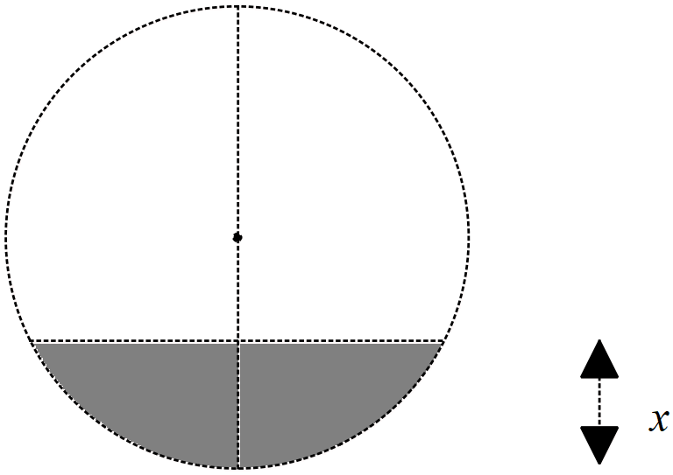

(a) Given that the volume $V$ between heights $a$ and $b$ is $\int_{a}^{b}{A\left(x\right) dx}$, determine the volume at heights between $2 m$ and $3 m$. (2 marks)

(b) Suppose that oil is being pumped into the tank at a rate of $50m^{3}/min,$ using the chain rule,

$\frac{dx}{dt}=\frac{dx}{dV}×\frac{dV}{dt}$, determine the rate of change of height of oil in the tank with respect to time, in terms of $x$. (Hint  ) (3 marks)

(c) Calculate the time (in minutes) that it takes to fill the tank from a fill level of $2 m$ to $3 m$. (2 marks)

**Question 19 (8 marks)**

When preparing to enter a road in a school zone, you hit the brakes on your car to reduce your speed to from $60 km/h$ to $40 km/h$ at a constant rate over $100 m$.

(a) Determine the acceleration in $m/s^{2}.$ Note that $1m/s^{2}≈12,960 km/h^{2}$. (6 marks)

(b) At the same acceleration rate, determine the time (in seconds) it takes for you to bring your car to a complete stop from $60km/h.$ (2 marks)

Additional working space

Question number: _______

Additional working space

Question number: ________

Additional working space

Question number: ________